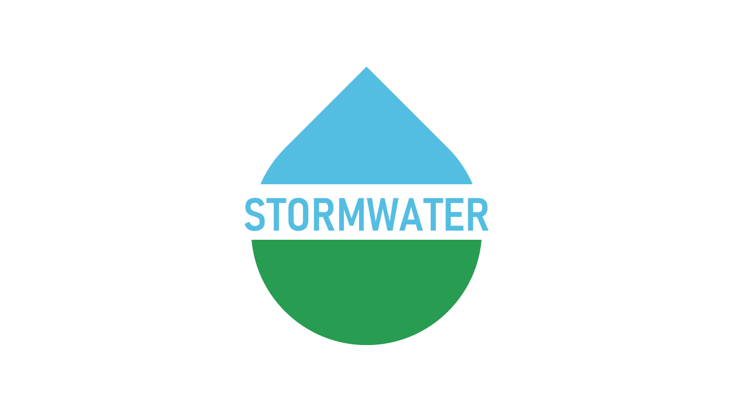

BERKELEY COUNTY

PUBLIC SERVICE STORM WATER DISTRICT
P.O. Box 944
65 District Way
Martinsburg, WV 25402
Phone: (304) 263-8566
Fax: (304) 267-7478

MEETING NOTICE

REGULAR MEETING
OF THE BERKELEY COUNTY
PUBLIC SERVICE STORM WATER DISTRICT

THE BOARD OF DIRECTORS OF THE BERKELEY COUNTY PUBLIC SERVICE STORM WATER DISTRICT SHALL CONDUCT A REGULAR MEETING ON TUESDAY 22, 2025 AT THE OFFICE OF THE BERKELEY COUNTY PUBLIC SERVICE SEWER DISTRICT, 65 DISTRICT WAY, MARTINSBURG, WV 25402.

___________________________
CURTIS B. KELLER DATE

