BERKELEY COUNTY

PUBLIC SERVICE SEWER DISTRICT
P.O. Box 944
Martinsburg, WV 25402
Phone: (304) 263-8566
Fax: (304) 267-7478
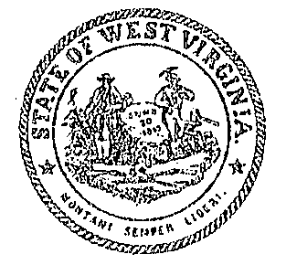
Board of Directors: Curtis B. Keller
John C. Kunkle, Chairman General Manager
Gregory S. Rhoe, Treasurer
John E. Myers, Secretary

AGENDA
REGULAR MEETING OF THE BOARD OF DIRECTORS OF THE
BERKELEY COUNTY PUBLIC SERVICE SEWER DISTRICT
September 16, 2025
5:00 p.m.

1. Open Meeting
A. Call to Order
B. Welcome
C. Roll Call
D. Approval of Agenda & Packet
E. Approval of Minutes for September 2, 2025

2. Citizen Participation

3. Project Updates
- Woods Lagoon WWTP Upgrade Project
- Change Order No. 4 – Discussion/Action
- Northwinds Package Plant Removal Project
- Resolution No. 5 – Discussion/Action
- Chopwood Pump Station Replacement Project
- Pay Request No. # 2 – Discussion/Action
- Ecolab Pretreatment Facility Compliance
- Spring Mills Pump Station Removal Project

4. Future CIP Projects

5. Management Reports
A. General Counsel
B. General Manager

6. Approval of Financials / Payroll for September 16, 2025

7. Executive Session
A. Contractual and Legal Matters

8. Adjournment

___________________________________________________________________________
The Berkeley County Public Service Sewer District reserves the right to rearrange items on the agenda as needed due to time constraints of the public or the Berkeley County Public Service Sewer District. The times listed are approximate times for discussion and may be changed by the Berkeley County Public Service Sewer District as needed.

