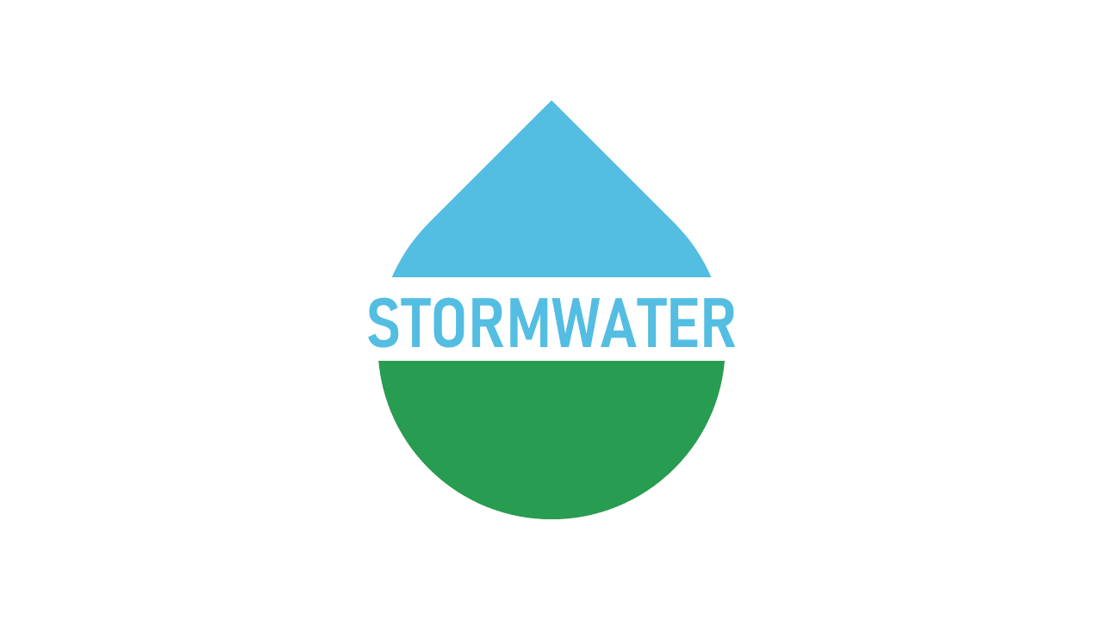

BERKELEY COUNTY

PUBLIC SERVICE STORM WATER DISTRICT
P.O. Box 944
65 District Way
Martinsburg, WV 25402
Phone: (304) 263-8566
Fax: (304) 267-7478

CANCELLATION NOTICE

REGULAR MEETING
OF THE BERKELEY COUNTY
PUBLIC SERVICE STORM WATER DISTRICT

THE BOARD OF DIRECTORS OF THE BERKELEY COUNTY PUBLIC SERVICE STORM WATER DISTRICT CANCELLED THE REGULAR MEETING ON TUESDAY, JULY 15, 2025 THAT WAS TO BE HELD AT THE OFFICE OF THE BERKELEY COUNTY PUBLIC SERVICE SEWER DISTRICT, 65 DISTRICT WAY, MARTINSBURG, WV 25402.

__________________________
CURTIS B. KELLER DATE

