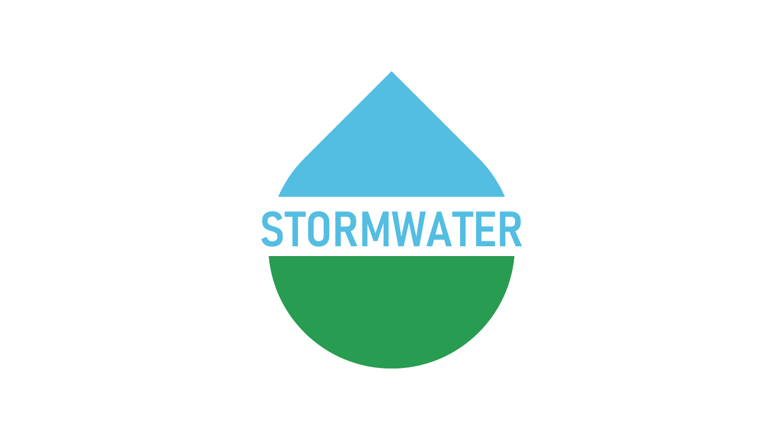

BERKELEY COUNTY

PUBLIC SERVICE STORM WATER DISTRICT
P.O. Box 944
65 District Way
Martinsburg, WV 25402
Phone: (304) 263-8566
Fax: (304) 267-7478

AGENDA
REGULAR MEETING OF THE BOARD OF DIRECTORS OF THE
BERKELEY COUNTY PUBLIC SERVICE STORM WATER DISTRICT
April 1, 2025
6:00 p.m.

1. Open Meeting
A. Call to Order
B. Welcome
C. Roll Call
D. Approval of Agenda & Packet
E. Approval of Minutes for March 18, 2025

2. Citizen Participation

3. Management Reports
- General Counsel
- General Manager

4. Approval of Financials for April 1, 2025

5. Executive Session
A. Legal and Contractual Matters

6. Adjournment

______________________________________________________________________________
The Berkeley County Public Service Storm Water District reserves the right to rearrange items on the agenda as needed due to time constraints of the public or the Berkeley County Public Service Storm Water District. The times listed are approximate times for discussion and may be changed by the Berkeley County Public Service Storm Water District as needed.

