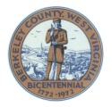
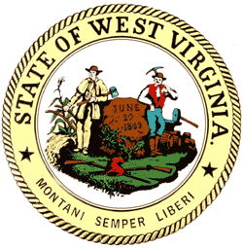
Berkeley County
Community Corrections
520 South Raleigh St.
Martinsburg, WV 25401
Phone: 304-262-9831
Fax: 304-262-9814

Berkeley County Criminal Justice Board Agenda
Wednesday January 15, 2025
4:00pm
Berkeley County Day Report Center
520 South Raleigh St. Martinsburg, WV 25401

- Call to order

- Approval of Agenda

- Items from the public

- Approval of Minutes

- Membership updates

- 1 vacancy - Public Defender

- BDRC Update
  - Building Project
  - Stats
  - DUI Program
  - Federal Probation
  - Staffing
  - Financial update

- Home Confinement update
  - Statistics
  - Staffing

- Community Service update
  - Stats
  - Staffing

- Recess

Next meeting will be April 16th, 2025 @ 4pm

