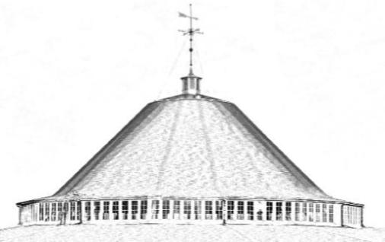

Berkeley County Roundhouse Authority
Board of Directors Meeting
Wednesday, January 8, 2025 – 6:30 PM
300 Foxcroft Avenue, Suite 201 - Martinsburg, WV 25401

Meeting Agenda

- Roll Call/Welcome of Guests
- Proof of Notice of Meeting
- Approval of Minutes of Previous Meeting
- Report of Treasurer
- Report of Chair
  - Capital Project & Event Updates & Correspondence
- Report of Standing Committees
  - Finance & Foundation: Roundhouse Night Market T-shirts for Sale; LEDA funding update
  - Building & Grounds: West Roundhouse Door Refurbishment; Track Groove Project Design
  - Artifacts & History: Committee of the Whole Heritage/Rail Fest event plan meetings
  - Executive: Call-in Meetings
- Unfinished Business
  - Discuss/take action as necessary regarding Roundhouse website
- New Business
  - Discuss/take action as necessary regarding endorsement of conceptual proposal to provide long-term, temporary display/storage space for the Friends of the Norwalk Foundation for the storage of antique vehicle in portion of Car Shop (future Farmers Market pavilion).
  - Approve/Deny Roundhouse Farmers Market management agreement with Sweet Willow Apiary LLC (dba Sweet Willow Farm) to operate 2025 farmers market from April 19, 2025 to October 25, 2025.
  - Approve/Deny Agreement with Sweet Willow Apiary LLC (dba Sweet Willow Farm) for Roundhouse Night Market (third Friday of May thru August; and third Saturday of September thru November) and 2025 Merry Makers Market at the Roundhouse, Dec 6-7; 13-14, 20-21.

- Other Business
  - Upcoming Events: Home Show 2025, March 29-30; Farmers Market 2025 Earth Day Kickoff, April 19; Spring Train Show/Rail Fest, May 10; Founders Day Fair, May 17; Roundhouse Night Market, May 17, June 20, July 18, August 15, September 20; October 18; November 15.
- Executive Session for legal matters (if necessary).
- Adjournment

Zoom: https://us02web.zoom.us/j/89208882224?pwd=EuwAsZXV1hpCp9d6ZnzFG2Kx4oUpjQ.1
Meeting ID: 892 0888 2224
Passcode: 693124

